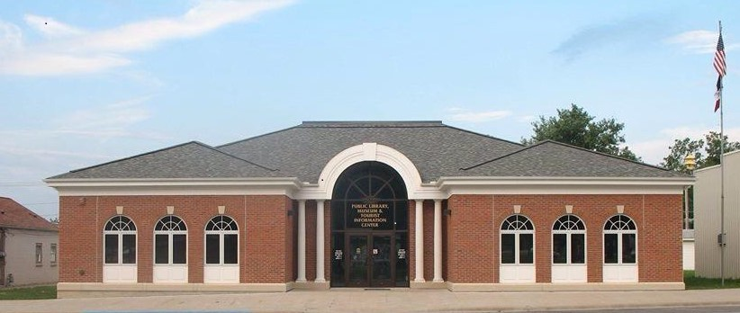
West Point Public Library
Library Card Application

By completing this application, I agree as a cardholder, parent, or guardian, to accept full responsibility for all materials selected and borrowed on the account listed below, including any lost, damage, or fines incurred. I agree to abide by all Library policies.

I agree to notify the Library if the card is lost or stolen. Failure to do so will result in my liability for all debts related to the account.
- I understand the borrowing period for most materials is two (2) weeks and one (1) week for STEM backpacks and Hotspots. Parents or guardians have the responsibility to monitor their children's access to Library materials.
- I understand that if Library materials are not returned for two months, they are considered stolen and that my contact information will be turned over to the West Point Police Department for retrieval.
- I will notify the library of any change in contact information, including address or telephone number.
- Accounts with any overdue library materials 14 days (two weeks) after due date or more than 3 items overdue at any one time, will have borrowing privileges suspended. Items not returned after 8 weeks are subject to replacement cost of the material(s).
- A maximum of two (2) renewals is permitted on most renewable items with the exceptions of DVDs and STEM backpacks with no renewals on Hotspots.
- Library cards expire yearly. Lost cards incur a $1.00 replacement fee.
- If an Open Access patron, Interlibrary Loans (ILL), access to downloadable materials, and Hotspot checkout, will be handled by the patron's "Home" library.
- Courtesy notifications regarding due dates, overdue materials, and reserves will be sent by text or email.
- There are no age restrictions for borrowing or using library materials and resources, including the Internet, with the exception of Hotspots (ages 16+).

------------------------------------First-time borrowers are limited to five materials two of which can be DVDs------------------------------------------

APPLICANT NAME: (Please print)

DATE OF BIRTH: GENDER

FIRST NAME MIDDLE NAME LAST NAME SUFFIX (Jr./I/etc.)

APPLICANT ADDRESS:
/ / MM DD YYYY
M / F

STREET/P.O. BOX (with proof of Iowa address) APARTMENT
Library Use Only

Date

Library Card #
Driver's License #

Address Verified
Other

ID Shown
Other
Age

Adult
Teen Child
Type
OA/Rural/WP/SP/HT
OA/Rural/WP/SP/HT OA/Rural/WP/SP/HT
Staff Initials

CITY COUNTY STATE ZIP CODE

TELEPHONE #1: TELEPHONE #2:
(Circle) HOME/CELL/WORK HOME/CELL/WORK

EMAIL: I live within the city limits of my town: YES / NO
I certify that the information provided is true and correct to the best of my knowledge.

Applicant Signature Date

*Applicants under age 12 require parent/guardian signature

Parent/Guardian

Print Name Relationship

I hear by accept full responsibility for all materials selected and borrowed on the account listed above, including any lost, damage, or fines incurred.

Signature Date
Driver’s License/State ID
Mail/Bill
Lease
Report Card

Driver’s License/State ID
School ID
Passport
Job Issued ID

Please present this form with a driver's license or other acceptable identification with current address and signature. This may include: valid driver's license; other Iowa state issued identification card, valid school ID, along with a piece of mail post marked within the last 30 days; a recent utility bill or lease and combined with a signature/photo ID. Students may submit progress or report cards from current term.

