West Point Public Library

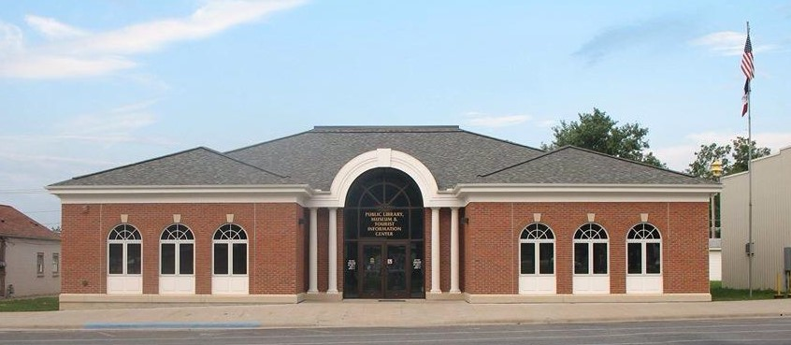

Strategic Plan 2026-2031

Approved by the West Point Public Library Board of Trustees on
March 10, 2026
Mission Statement

The mission of the West Point Public Library is to enrich the quality of life in the community by supporting lifelong learning, stimulating a desire to read, and serving community needs.

Community
West Point is located in Lee County in Southeast Iowa. The population of West Point has shown a slight decrease since the 2010 Federal Census. Based on the 2020 Federal Census, the current population is estimated at 921. The community is fairly balanced with no significantly large population of any particular age group. The median age is 43.1. The residents of West Point are predominantly white. English is the principal language spoken in the community.
There is one licensed daycare center and one preschool in West Point. Parents also rely on in-home daycare providers. The children of West Point have a variety of public and private options for attending school. Children living in West Point fall within the Ft. Madison School district with all schools being located in Ft. Madison. Another option is Holy Trinity Catholic, with schools located in West Point and Ft. Madison. In addition, some parents choose to open enroll their children to other surrounding community school districts. It is estimated that there are 6 home school families in the community, which has doubled over the past five years. Excluding preschoolers, approximately 19% of the population is school age. In addition, 34.9% of the population of West Point are high school graduates, with 14.6% having obtained an Associates degree, 16.5% having a Bachelor’s degree, and 8.1% having a Master’s degree or higher.
The community’s main employers include Merschman Seed, Holy Trinity Catholic Schools, Pilot Grove Savings Bank, and Menke & Company as well as the City of West Point and Lee County. Because of our close proximity to larger towns, Ft. Madison, Mt. Pleasant, Keokuk, and Burlington, most residents choose to commute with the mean travel time being 17.7 minutes. Median household income in this community is $66,000 which is below the state average of $71,433 and a 3.3% unemployment rate.
The community boasts many amenities. Local organizations include West Point Community Club, American Legion, and West Point Public Library Foundation. There are also two churches in town as well as three recreational areas, including the West Point Town Square, South Park, and Pollmiller Park. The citizens take pride in the many amenities provided by their community, varied community groups, and their Catholic school system.

(All statistics are courtesy of the Iowa State Data Center)

Introduction
In October 2018, the Board of Trustees of the West Point Public Library initiated the Strategic Planning Processes for the City of West Point, IA. The library board wanted the plan to reflect the needs of the community as a whole so they formed a Community Planning Committee of 18 individuals. This committee worked to envision the future of the city and provide direction for the library’s operations for the next five years (2019-2024).
The West Point Public Library is updating its five-year strategic plan to reflect both the extensive community input gathered during the development of the original plan in 2019 and the objectives that remain relevant today, rather than rewriting the entire document. This update will also incorporate input from library staff and Library Board Trustees along with updated census data — including current unemployment rates and the age demographics of community members — to help inform decisions and ensure the plan continues to meet the evolving needs of the community for the next five years (2026-2031). The following areas of focus will continue to be addressed:
- Connect, Communicate, and Collaborate
- Foster Lifelong Learning, Literacy, and Life Skills
- Discover a Safe and Welcoming Space
This plan outlines goals, objective, and activities that will help library staff continue to meet the needs identified. The West Point Public Library Strategic Plan is submitted as a written endeavor to accomplish the goals set forth by the previous community committee members as well as current staff and Trustees.

*Library Board of Trustees
Carl Johnston, President
Vicky Lundeby, Vice President
Mary Link
Pat Krogmeier, Secretary
Suzanne Menke
Melinda Robey
Bob Winnike

*Library Staff
Dara Sanders, Director
Becky Sanders, Assistant Librarian
Ronda O’Keefe, Assistant Librarian

Library Areas of Focus, Goals, and Objectives
CONNECT, COMMUNICATE, AND COLLABORATE
Our community will find a central source for information about the wide variety of programs, services, and activities provided by community agencies and organizations. The library will provide resources and foster connections needed to develop and maintain strong, viable organizations and businesses.

Goal #1: Residents find a variety of ways to learn about the library.
Objective 1: A new logo will be developed for the West Point Public Library.
- Seek design logo ideas (2027)
- Introduce Logo (2027)
- Begin to use logo on letterhead, policies, website, etc. (2028 – 31)

Objective 2: Promote the library in community and contracting towns.
- Update library brochure on yearly basis (2026 – 31)
- Distribute library brochure to contracting towns (2027 – 31)
- Attend yearly board meeting in contracting towns (2028 – 31)

Goal #2: Students are aware of library resources.
Objective 1: Partner with Lee County librarians to increase awareness of local libraries in schools.
- Meet with other librarians and discuss possible opportunities (2026-27)
- Visit local schools to promote Summer Reading Program (Summer 2028 – 31)
- Create “Did you know” flyers and distribute to local schools, preschools, and daycares – (2028 – 31)

Objective 2: Provide in-service to teachers and/or students at local schools
- Local school will take one field trip to library per year (2027 – 31)
- Provide in service to teachers and/or students focusing e-books/audiobooks (Libby/Hooopla), library website including kids catalog, data bases (2028 – 31)

FOSTER LIFELONG LEARNING, LITERACY, AND LIFE SKILLS
Our community will have library resources to support schoolwork and independent learning at every age, helping to build skills and interests needed for life-long success. The library will connect them to information and services for the variety of skills they need to thrive and grow as citizens.

Goal #1: All West Point preschoolers have access to quality, age-appropriate books.
Objective 1: Investigate early childhood programming for library.
- Research 1,000 books before Kindergarten program (2027)
- Chose program and initiate implementation (2028)
- Program fully implemented (2029 – 31)

Goal #2: Early elementary age children find resources and services to satisfy their interests.
Objective 1: Increase children’s access to age-appropriate STEM and technology.
- Upgrade AWE station and, if needed, secure funding (2026)
- Investigate Maker Space Kits (2028)
- Buy/Develop maker space kits to be used in library (2029 – 31)

Goal #3: Patrons find a well-organized, up to date collection of materials and resources.
Objective 1: Library will regularly weed materials that are noncirculating, outdated, and/or damaged.
- Develop Weeding schedule (2026-27)
- Library will be weeded using Crew Manual recommendations on a yearly basis (2026 – 31)
- Develop Inventory schedule (2026 – 27)
- Conduct Inventory (2027 – 28)

DISCOVER A SAFE AND WELCOMING SPACE
Our community will be drawn to comfortable and safe library environments that reflect the community’s changing needs. The Library will cultivate a sense of belonging for everyone whether they are looking for social connection or private spaces.

Goal #1: Maintain a safe, functional, and well-communicated library facility that supports staff effectiveness and protects patrons and collections.
Objective 1: Library will replace cabinets.
- Contact contractors for quotes (2026)
- Select contractors and identify/secure funding sources at Board Meeting (2026)
- Empty/clean cabinets (2026)
- Install cabinets (2026)

Objective 2: Library will replace roof.
- Create a Clear plan (2026 – 27)
- Define Roles and Leadership (2026 – 27)
- Discuss Financing (2026-27)
- Discuss bidding process (2027 – 28)
- Contractor outreach (2027 – 28)
- Acquire Bids (2027 – 28)
- Award Bid (2028)
- Install Roof (2028 – 29)

Objective 3: Building Maintenance
- Conduct site inspection (2026 – 27)
- Identify areas of need (2026 – 27)
- Develop a schedule to address identified areas (2027 – 31)
- Identify funding sources

Strategic Plan Evaluation
The West Point Public Library Board will evaluate this strategic plan during its regularly scheduled March meeting. The board will evaluate the progress made toward achieving this plan’s goals and objectives by reviewing areas of success, as well as determining whether unmet goals/objectives are still valid and relevant to the library’s mission.
The West Point Public Library Board will also evaluate whether new goals and/or objectives should be added to meet additional community needs.

Approved 3/10/2026

